Access to the iCIMS Enhancements

We have highlighted the iCIMS enhancements below in yellow to show you the screens where the enhancements are located within the system (as described in HR Capsule article, iCIMS Enhancements - HR Capusle Article (Feb. Issue)”.)
- Creating a New Job Requisition Section.
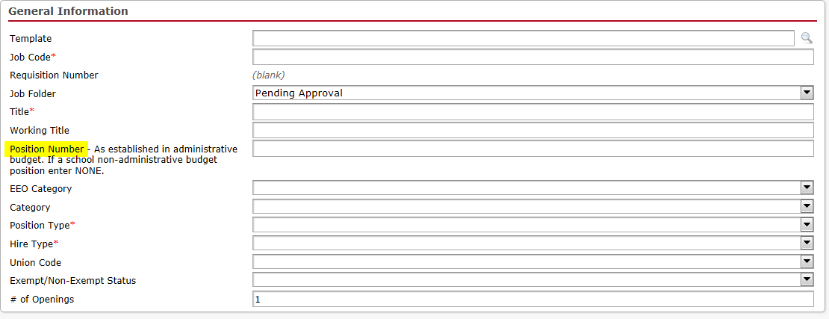
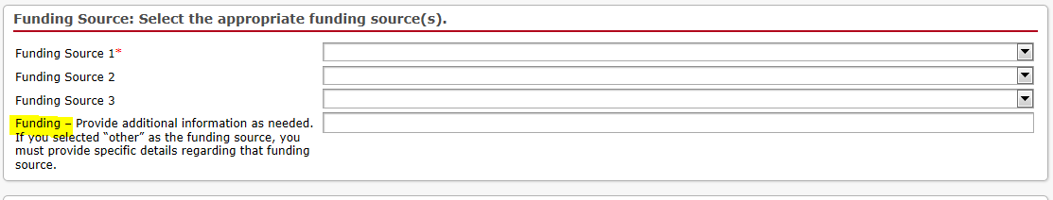

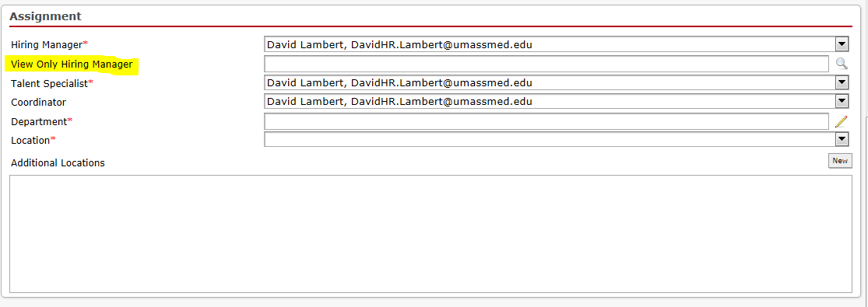
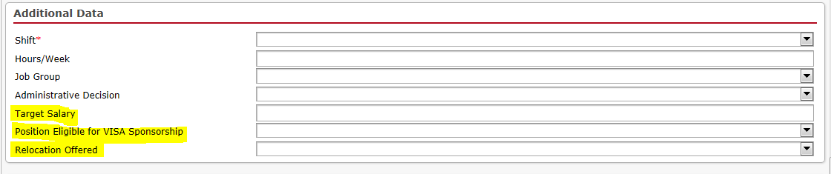
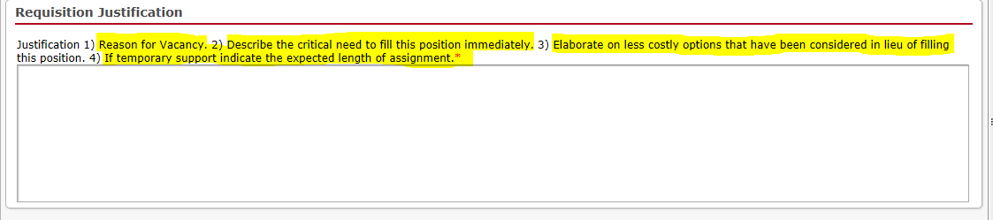
For more details on the Creating a New Job Requisition process, please click on the iCIMS Hiring Manager User Guide (pages 8-14).

- Job Requisition Approval Process Section
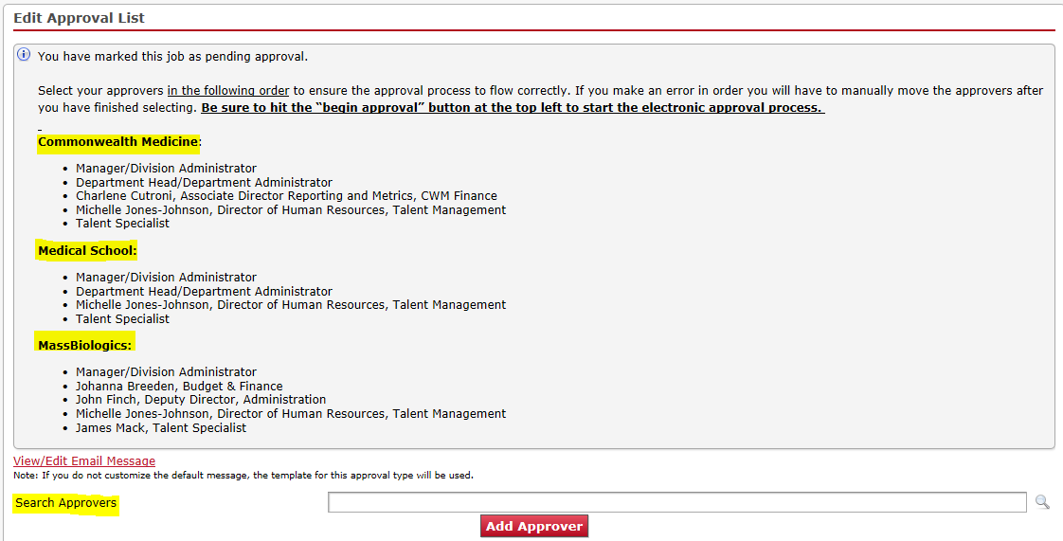
For more details on the Job Requisition Approval process, please click on the iCIMS Hiring Manager User Guide (pages 15-17).

